Brd4 report   
Gavin Unrue  
ECEN 3730  
12-8-2024

Contents

Introduction 1

POR 4

Risk reduction 2

Circuit sketch 2

Circuit schematic 3

Altium layout 6

Assembled board 7

Scope captures 8

Analysis 13

What went wrong/future improvements 13

What worked well 14

Conclusion 15

## Introduction

The Thevenin voltage and resistance of a power source describe what the internal resistance of the power source is along with the unloaded voltage of said source. This can be found manually by connecting a load to a power source and measuring the voltage at the point connecting the load and the source. This creates a voltage divider, which is described by the following equation:

$$ν_{0}=v_{i}\left(\frac{R2}{R_{1}+R2}\right)$$

The Thevenin resistance can be found easily by first measuring the unloaded voltage of the source and solving for r1, with r2 being the value of the load. This board automatically determines the value of rth and vth by reading the unloaded voltage of a source, and by allowing a small amount of current across a sense resistor a regular intervals to solve for the thevienin resistance. This board should be able to plug into an arduino via the headerpins, and read the thevenin voltage and resistance from three different terminals, a barrel jack terminal, a screw jack terminal and a usb mini terminal. There is also an onboard buzzer and smart led indicator which indicates the start and end of a voltage read cycle. This board is made with four layers, which has allowed for easier signal routing and the potential for higher board complexity.

Testing of this board was conducted via four different power sources to test the boards ability to switch between all three of its measurement terminals. The sources are as follows: a bench oscilloscope function generator (screw jack), a bench function generator( screw jack), a 5v power adapter (usb mini), another 5v adapter (barrel jack). Since the most amount of datapoints were able to be collected via the usb mini 5v adapter, onboard measurements were collected while data acquisition occured for this source.

## Risk reduction

There are many potential risk sites for this board, for one is the close proximity of the switches and headers to other components in the board. In the case that there are any mistakes that require resoldering of components, I would need to desolder these to access whatever needs soldering. This time during the assembly process I plan on using a high-powered microscope to solder components to the board, which should cut down on assembly errors.

 Another risk site is accidentally using the wrong capacitors when soldering the board together. To avoid this issue, I will have my laptop open with reference documents while I solder, to ensure everything will be soldered with the proper components.

In addition, another thing that could go wrong is that I could accidentally burn out my eyes with splashes of stray solder when soldering. One way to avoid this is to wear safety goggles while soldering.   
  
Another thing that could go wrong is that I solder the IC's upside down. I will also have reference documents pulled up while I solder to combat this, and make sure the chip orientation matches that found online.

Another issue is that I might accidentally lose some of the components. The way I plan on handling this potential issue, is to only pull-out components one at a time, when I am ready to solder them. I also plan on doing my soldering in an isolated room, preventing the components being lost by various table movements caused by other people.

## Circuit sketch

Figure , basic sketch of brd4 circuitry

* As seen in the figure, the voltages are read by an ads115 chip which also compares the voltages to local grounds to prevent possible noisy ground interference.
* As seen in the figure, an i2c connection is made to the DAC to indicate it should send out a voltage to the opamp. The opamp is in a comparator configuration.
* Before any current is let through the mosfet transistor, the voltage at v current is equal to zero. This means that any voltage higher than ground will enable the output of the opamp, allowing current through the mosfet.
* This is a slammer circuit, and is used in situations where a circuit enabling a larger circuit does not have access to the current required for the larger circuit's operation.
* As a result, the slammer circuit is used to drive said larger circuit with a source that can provide said current i.e. the measured power source.
* The microcontroller enables the dac at a duty cycle of 10% to prevent the sense resistor from overheating.
* The DAC gradually ramps up its input voltage so as to create a range of voltage readings. This allows for a user to, if desired, take an average of values and therefore increase reading accuracy. Since stepping up the voltage on the opamp also increase the current through the transistor controlling the path from rth to rsense, a range of voltages is created as more current passes through rsense from the opamp.

## Circuit schematic

Figure , brd4 schematic

* As mentioned in the improvements to be made section, the TP block is missing a DAC TP, along with an opamp TP.

## POR

The following table contains requirements for each block of this board to be considered a success.

|  |  |
| --- | --- |
| **Header pin block** | Are header pins properly aligned with Arduino header pins? |
|  | Are the vrm sources properly connected to board? |
|  | Is onboard SDA/SCL communication pins default high level within required threshold? |
| **Data collection block** | Does the DAC gradually ramp up input voltage at a 10% duty cycle? |
|  | Does the OPAMP permit DAC voltage with DAC input? |
|  | Does mosfet allow current upon high level voltage at gate pin? |
| **Measurement block** | Is there minimal difference between input and read voltages? |
|  | Does a simple I2C address detection program detect ads chip? |
| **Indicator block** | Can different tones be produced by onboard buzzer? |
|  | does the 5v indicator flash when board is plugged in? |
|  | Can the smartled cycle through different colors? |
| **Switches block** | do switches enable/disable desired functionality? |
| **General** | Is read rth/vth accurate? |

Table , POR requirements

## Altium layout

Figure , layout of front of brd4

* The signals routed on the front of the board are in red, and the signals routed on the back of the board are in blue.

Figure , layout of the back of brd4

* Here the view for the silk screen is disabled in order to make viewing of the board easier. Otherwise the QR code obscures the circuitry. Future designs will not have a QR code directly on top of circuitry, or at least another version of the file will be made for the QR code in the final step of the design process.

## Assembled board

Figure , The front side of the assembled board

* As you can see in the image, the led state indicator was fully functional during testing. Moreover, scope captures of the buzzer indicator are present later in this report.

Figure , the back side of the assembled board.

* One can see that c14 is missing, which is mentioned in the what went wrong section where one of the pads became disconnected from the board during assembly. Due to the size of the ADS115 voltage reader chip, I had an extremely difficult time soldering this component to the board.

## Scope captures

Figure , steady state buzzer signal, 6vpp amplitude, 2.5khz

* The buzzer signal is rather noisy here, so in future designs perhaps a decoupling capacitor could be used to improve sound quality, if necessary.

Figure , buzzer signal startup

* It appears that the buzzer signal starts its signal with a brief period of high output, then gradually eases into the 2.5khz steady state signal.

Figure , UM test V current (green)(2.8v max) vs dac vout (yellow)(2.72v max) [test duration: 21 seconds]

* This scope capture and anything labelled under the UM test occurred with the USB mini power source. The serial output corresponding to this scope capture can be found below in this section.

Figure , UM test v current (green)(2.8v max) vs opamp vout (yellow)(4.13v max)[test duration: 21 seconds]

Figure , UM test serial monitor output. column1 = item #, col2=measured current in mA, col3=vth, col4=vcurrent, col5=calculated rth.

* As seen in the serial output above, the 5v power source was measured to be at a voltage of 5 volts. This indicates that the ads115 chip is properly reading input voltages.

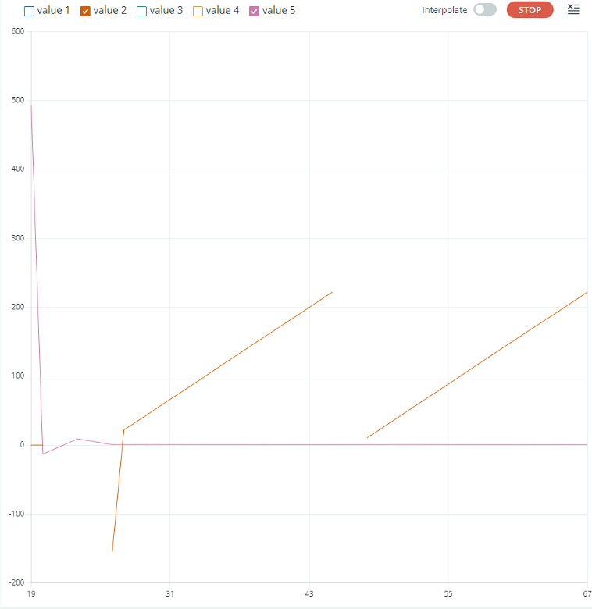

Figure , UM test serial plotter. Orange is measured current in mA, purple is measured Rth

Figure , function generator test serial monitor output. column1 = item #, col2=measured current in mA, col3=vth, col4=vcurrent, col5=calculated rth.

Figure , function generator test, orange is measured current in mA, purple is measured Rth

Figure , Oscilloscope function generator test, column1 = item #, col2=measured current in mA, col3=vth, col4=vcurrent, col5=calculated rth.

Figure , Oscilloscope function generator test serial plotter, orange is measured current in mA, purple is measured Rth

Figure , Barrel jack adapter test, column1 = item #, col2=measured current in mA, col3=vth, col4=vcurrent, col5=calculated rth.

## Data

Table , UM test results

|  |  |  |
| --- | --- | --- |
| **UM test data** | **Measurement** | **Unit** |
| usb mini test max v current voltage | 2.8 | v |
| usb mini test duration | 21.09 | s |
| UM dac max voltage | 2.72 | v |
| UM op amp max voltage | 4.13 | v |
| dac increment amount | 0.2 | v |
| UM op amp min voltage | 1.73 | v |

Table , Measured rths vs actual rths

|  |  |  |  |
| --- | --- | --- | --- |
| **Test name** | **Measured rth** | **actual rth** | **Difference** |
| Usb mini (UM) | 0.66 | 0.55 | 0.11 |
| Barrel jack test | 0.2 | 0.4 | 0.2 |
| Function generator (screw jack) | 50.66 | 50.4 | 0.26 |
| Oscilloscope (screw jack) | 50.85 | 50.3 | 0.55 |

Table , Buzzer characteristics

|  |  |  |
| --- | --- | --- |
| **Buzzer data** | **Value** | **Unit** |
| vpp | 6.06 | v |
| frequency | 2500 | hz |

## Analysis

There is minimal difference between the measured rth and vth for all of the power sources. Despite the header pins not being properly aligned on my design, I consider this board a success since it fulfills all items on the POR. An in-depth analysis of why the header pins did not match up can be found below.

## What went wrong/future improvements

There was a variety of issues that occurred during the course of brd4’s development.  
One of these issues was that the width of the header pins was somehow miscalculated during the design process, which led to the power and gnd signals requiring jumper wires to be connected to the board’s power signals. During the design process of brd3 an excel sheet was used to calculate the relative spacing of all other header pins given a reference pin width. The spacing value of this reference header pin was calculated for based on the spacing of one of the pins, which was then used to calculate the spacing of the other header pin. This was double checked afterwards by copying the header pins of board 3 and superimposing them over the header pins of brd4, which yielded identical positions. This leads one to conclude that the header pins must have been accidentally shifted somehow before the design was submitted. A potential way to prevent this in the future would be to perform a rapid design check before submitting a design, as a triple measure of its integrity.

Another issue was that when the assembled board was plugged into an Arduino, the type b usb port of the Arduino would make contact with some components of the board. The outer casing of a usb b port is connected to ground, which interfered with the operation of my board. As a result, some material had to be placed in between the board and the port. In future designs I plan on considering the physical layout a little more in detail, to prevent issues such as this from occurring.

Another issue I experienced was that due to a board of lesser quality, while soldering a component to the board one of the pads of capacitor c14 melted off of the board. Luckily this was not to an important connection, so the board worked just fine following this. One workaround to this in future designs is to add in additional, redundant routing pathways on important signals to component connections if a cheaper board is to be used.

I had issues with soldering the ads115 chip due to its size, which ultimately led to complications in its ability to read voltages. After spending some time resoldering the chip, it began to work again. One way to avoid this issue in the future would be design more boards with smaller chips such as the ads115, to get more practice with soldering components of that size.

In addition, I also forgot to add in a test point for the DAC and opamp outputs, so during the data collection phase I had to hold the oscilloscope probe onto the pins of each IC long enough to collect the data necessary.

## What worked well

This time during the design process I began with a board with the largest possible size and stuck with it to prevent the issues I had with size restrictions on my previous designs. This was highly effective, as I had no issues with routing on brd4.   
  
My previous design for board 3 was not fully committed to the usage of net labels due to aesthetic preferences. For brd4 I decided to use more net labels and found there were many advantages to such a practice. This allowed circuits to be replicated and integrated into a larger circuit simply by changing the name on the output net labels. In the future it will be advantageous to repeat this design practice.

Design with four layers made routing incredibly easy, which is something I plan to carry forward in future designs.

I discovered a metal soldering platform in the soldering room and used it in the assembly of brd4. This made it so that the board did not shift around while soldering items to it. While this meant that the entire apparatus needed to be shifted to center the component of focus in the microscope, it did greatly assist in reducing movement while soldering the board. If I do any more PCB designs in the future, I plan on using said platform again.

Moreover, a reduction in caffeine intake has reduced assembly mistakes.

## Conclusion

The design of this measurement device has been very informative and has opened my eyes to possibilities for future designs. Although I did not add a microcontroller into brd4 like some other designs for brd4, the cumulative effort of brd3’s design along with brd4 has taught me the skills necessary to create smart measurement devices in the future. The usage of the onboard buzzer and smart led has opened up greater possibilities for user interaction with future design, and possibly more compact and energy efficient onboard indication designs. Surely this experience will enrich my life for years to come.